Unit 2A Study Guide:
Vocabulary (Definitions: Pg 110, pg 142.):

Point of View
Dialogue
Dialogue Tags
Persona
Theme
Symbols
Narrative Pacing
Sequence of Events
Setting
Direct/Indirect Characterization
Gutter
Panel
Dialogue Balloons
Thought Bubbles
Captions
Sound Effects

Examples: Kaffir Boy (pg 122, Funny in Farsi pg 117)
Find examples of each of the following from a work we have studied, and write your example and explain how that technique is used in your example:

Narrative Pacing:
_______________________________________________________________________________________________________________________________________________________________________________________________________________________________________________________________
Dialouge/Dialogue Tags
_______________________________________________________________________________________________________________________________________________________________________________________________________________________________________________________________
Direct/Indirect Characterization:_________________________________________________________________________________________________________________________________________________________________________________________________________________________________________________
Sequence of Events: _______________________________________________________________________________________________________________________________________________________________________________________________________________________________________________________________

Persepolis Graphic Novel Excerpt and Terms ( pg 142-151)
Review elements of a panel and be able to label them.
Example:

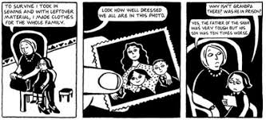

Does this set of panels have any of the following? Label and explain.

Gutter
Dialogue Balloons
Thought Bubbles
Captions
Sound Effects

